**CS610 Applied Machine Learning**

**Detection of Spoiled Meat  
to Prevent Foodborne Illness**

|  |  |
| --- | --- |
| **Name** | **Student Number** |
| NGUYEN THUY HANH DUYEN | 01480970 |
| QIU RUILIU | 01480261 |
| SAMSON ELIJAH CHUA TAN | 01450282 |
| TAI WEN WEI | 01254422 |
| WEN YILIN | 01479807 |

Contents

1. Overview 3

2. Background Information 3

*3.* Dataset *(Source, Preparation and Pre-Processing)* 3

4. Performance Metrics 4

5. Traditional Model Benchmarks 4

6. Performance of Self-built Artificial Neural Network (ANN) and Convolutional Neural Network (CNN) 4

7. Pre-Trained Model and Results 6

8. VGG16 Fine Tuning and Results 8

9. ChatGPT Performance 10

10. Conclusion and Future Works 10

11. References 11

12. Appendix 12

# Overview

Access to enough safe and nutritious food is key to sustaining life and promoting good health. Unsafe food that contains harmful bacteria, viruses, parasites, or chemicals can lead to over 200 diseases, ranging from nausea, fever and perhaps even cancer (World Health Organization, 2022). Ingestion of such bacteria typically will result in gastroenteritis, where the symptoms typically include but not limited to are nausea, fever, bloating and vomiting (Johns Hopkins Medicines, n.d.). Vulnerable groups, including young children, seniors, pregnant women, and individuals with chronic diseases, face a higher risk of fatality if food safety is not properly managed.[1]

An estimated of 600 million people fall ill after eating contaminated food, leading to approximately 420,000 deaths annually. (World Health Organization, 2022) As global meat consumption continues to rise steadily over the years (Statista, 2024), ensuring the safety of food becomes increasingly crucial to prevent further casualties and fatalities. A robust system needs to be implemented to track meat quality before consumption. In this research paper, we will be exploring Artificial Intelligence technology and will be utilizing Machine Learning to evaluate the effectiveness of the various models (Qing, Zhang, & Wang, 2022).

# Background Information

The predominant bacteria associated with spoilage of refrigerated beef and pork, are *Brochothrix thermosphacta*, *Carnobacterium spp*., *Enterobacteriaceae*, *Lactobacillus spp*., *Leuconostoc spp*., *Pseudomonas spp*. and *Shewanella putrefaciens* (Borch, Kant-Muermans, & Blixt , 1996). It is known that bacteria are a few of the microbes that can generate natural colors (Agarwal, et al., 2023). A snapshot of the listed bacteria is provided in the appendix as ***Figure 2***.

Deep learning models can classify images by breaking them down into their RGB values and using convolutional layers to detect patterns and features at various levels of abstraction. (Nisha, Sathik, & Meeral, 2020). As a result, we will be exploring the various Machine Learning models, including self-built ones, to see which the best model is to detect whether the meat has turned stale.

# Dataset *(Source, Preparation and Pre-Processing)*

A total of 2,268 labelled images *(Fresh, Half-Fresh, Spoiled)* has been downloaded from Kaggle[2]. These images are split into 2 separate folders, Training Set *(1,816 labelled images)* and Validation Set *(452 labelled images).* The dataset is insufficient in size for training a large-scale model. Given the limited available public data, synthesizing fake images or oversampling/downsampling the categories was deemed not beneficial. Instead, the ImageDataGenerator from the Keras library will be utilized for data augmentation. This tool creates different versions of existing images, ensuring that the model trains on varied image versions during each epoch. This approach enhances generalization and prevents overfitting. The Keras library allows for the conversion of image data into PIL numerical format, normalization of pixel values from 0 to 1, batch-wise image augmentation, and resizing of images to 224 x 224 pixels, which is the conventional input size for most pretrained models.

# Performance Metrics

Given the potentially life-threatening effects of consuming spoiled meat as outlined in previous sections, it is crucial that the selected models minimize false negatives, specifically cases where the model predicts ‘Spoiled’ meat as ‘Half-fresh’ or ‘Fresh’. Thus, recall from the perspective of ‘Spoiled’ meat is a critical metric, as it measures the proportion of correctly detected ‘Spoiled’ meat instances. Given the importance of recall, the F3 score is the focus in terms of performance metrics. It is calculated using the following equation:

$$\frac{\left(1+β^{2}\right)*Precision*Recall}{β^{2}*Precision+Recall}$$

where $β$ is 3, giving more weight to recall compared to precision. The F3 score is chosen as the critical metric over the F2 score due to the significant importance of not inaccurately mislabelling ‘Spoiled’ meat.

# Traditional Model Benchmarks

Traditional machine learning models are often insufficient for processing images due to the geospatial and high-dimensional nature of image data. To quantify how much better neural networks are at classifying images, traditional models such as Naïve Bayes, Logistic Regression, and Random Forest were evaluated. These models achieved F3 scores of 68%, 54%, and 67%, respectively.

The classification reports (seen in ***Figure 3***) for these models indicate that they do not perform well in effectively classifying spoiled meat due to their inherent limitations. Naïve Bayes assumes that all features (individual pixels) are independent, which is not true for images, where pixels are highly correlated with neighbouring pixels. Logistic Regression expects a linear decision boundary to separate classes and cannot capture the complex non-linear relationships present in spoiled meat images. Lastly, Random Forest struggles with the unstructured nature of images, where individual pixels offer little predictive power in making effective splits.

These limitations underscore the need for more sophisticated approaches, such as neural networks, which are better suited to capture the complex patterns and relationships inherent in image data.

# Performance of Self-built Artificial Neural Network (ANN) and Convolutional Neural Network (CNN)

Shown as the ***Figure 4***, the ANN model we developed begins with an input layer that processes images sized 224x224 pixels, each having three color channels. These images are then flattened into a one-dimensional vector to ensure compatibility with subsequent dense layers. The initial dense layer, activated by ReLU, extracts essential features from the input data. To mitigate overfitting, a dropout layer with a 20% rate is introduced. Following this, a second dense layer further refines the features, and another dropout layer is applied for additional regularization. The final output layer comprises three neurons, corresponding to the classes Fresh, Half-Fresh, and Spoiled, utilizing the Softmax activation function to produce class probabilities.

For model compilation, we opted for the Adam optimizer, Categorical Cross Entropy as the loss function, and accuracy as the performance metric.

The confusion matrix on the left of ***Figure 5*** highlights the ANN model's difficulties, particularly with the Half-Fresh category, which exhibits high misclassification rates. While Fresh samples have a high recall of 81%, indicating that the model correctly identifies most Fresh samples, the Half-Fresh class has a low F1-score of only 19%, reflecting significant challenges in accurate classification.

In ***Figure 6***, The accuracy curve shows noticeable fluctuations, suggesting instability in the model's learning process. This variability indicates that the model's performance varies significantly across different epochs, which may be due to the complexity of distinguishing between the categories or the need for more training data. Additionally, the loss curve shows that the model does not suffer from overfitting, as the training and validation losses remain relatively close. However, the need for further tuning is evident to improve overall performance.

Our CNN architecture, depicted in ***Figure 7***, begins with an input layer that processes images sized the same. The first convolutional layer applies 32 filters with 3x3 kernels and uses ReLU activation to capture essential features. This is followed by a max pooling layer with a 2x2 window, which reduces the spatial dimensions and computational load, and a dropout layer to prevent overfitting. This sequence is repeated in the next convolutional layer, which uses 64 filters with 3x3 kernels to further enhance feature extraction. Another round of max pooling and dropout layers ensures further reduction of spatial dimensions and continued regularization. Finally, the data is flattened, preparing it for the dense layers that follow.

***Figure 8*** presents the performance evaluation of the CNN model before fine-tuning. The confusion matrix illustrates that the model performs well in classifying Fresh and Spoiled meat samples, with the Fresh class achieving a high recall of 81% and the Spoiled class attaining a recall of 93%. However, the Half-Fresh category shows a comparatively lower recall of 65%, indicating room for improvement in distinguishing this class. Specifically, an impressive F3 score of 90% indicates the model's effectiveness in minimizing false negatives for spoiled meat.

***Figure 9*** demonstrates the performance of the CNN model after fine-tuning. The overall F1 score has increased to 83%, reflecting a more balanced performance across all classes. The Fresh class sees a slight improvement in precision, achieving an F1 score of 87%. The Half-Fresh class shows a substantial increase in recall to 89% and an F1 score of 79%, indicating that the fine-tuning has effectively enhanced the model's ability to accurately classify this category.

However, the F3 score for the Spoiled class decreased to 73%. This reduction suggests a trade-off where improving the model's general performance led to a slight reduction in its sensitivity to detecting spoiled meat. It can be attributed to the model prioritizing a balanced performance across all categories, which may have inadvertently affected the precision for the Spoiled class. The model's fine-tuning likely involved adjustments that enhanced its ability to generalize better, thus reducing overfitting to specific classes but slightly impacting its precision in detecting the Spoiled category.

Our self-built models demonstrate effectiveness, especially after fine-tuning, which enhanced its performance across most categories. Despite these improvements, the model still requires further refinement, particularly in achieving balanced precision for all classes. To overcome these challenges, we plan to explore mature pre-trained models, which may provide more robust feature extraction and classification capabilities for more accurate results.

# Pre-Trained Model and Results

**Pre-Trained Model Details**

In enhancing our custom ANN/CNN model, we explored the use of five pre-trained models known for their prominence in the field. These models were chosen based on their widespread use and recognition within the machine learning community. ***Figure 10*** shows a detailed description of each model, highlighting their attributes and unique features that contribute to their effectiveness.

**Pre-trained Models Performance Comparison**

##### **1. *ResNet50***

This model employs the ReLU activation function to introduce non-linearity, the Adam optimizer to efficiently minimize the loss function, and is trained for 20 epochs to ensure sufficient learning.

The confusion matrix in ***Figure 11*** indicates that the model has a relatively high accuracy in identifying Fresh and Spoiled samples but shows a higher rate of misclassification in the Half-Fresh category. ***Figure 12*** is our classification results.

* **Fresh:** The model correctly classified 157 samples as Fresh, while 9 Fresh samples were misclassified as Half-Fresh, and 12 were misclassified as Spoiled.
* **Half-Fresh:** Among the Half-Fresh samples, 64 were correctly classified, 79 were misclassified as Fresh, and 16 were misclassified as Spoiled.
* **Spoiled:** For the Spoiled category, 101 samples were correctly classified. However, 12 Spoiled samples were misclassified as Fresh, and 1 was misclassified as Half-Fresh.

An F3 score of 0.88 indicates that the model is effective in identifying Spoiled meat. Low F3 might be particularly harmful in our application, as they pose a risk to consumer health.

***Figure 13*** shows the Accuracy Curve and Loss Curve of the ResNet50 model. Training and validation accuracy rapidly increase to about 70% by the 5th epoch, stabilizing around 76% by the 20th epoch. The general upward trend in accuracy and the downward trend in loss demonstrate effective learning. The close alignment between training and validation metrics indicates good generalization, with some fluctuations pointing to areas for improvement.

#### **2. EfficientNetB0**

This model employs the ReLU activation function to introduce non-linearity, the Adam optimizer to efficiently minimize the loss function, and is trained for 20 epochs to ensure sufficient learning.

The confusion matrix in ***Figure 14*** indicates that the model has a high accuracy in identifying all categories, with particularly strong performance in the Spoiled category. ***Figure 15*** is our classification results.

* **Fresh:** The model correctly classified 136 samples as Fresh, while 42 Fresh samples were misclassified as Half-Fresh, and none were misclassified as Spoiled.
* **Half-Fresh:** Among the Half-Fresh samples, 147 were correctly classified, 12 were misclassified as Fresh, and none were misclassified as Spoiled.
* **Spoiled:** For the Spoiled category, 112 samples were correctly classified. However, 2 Spoiled samples were misclassified as Half-Fresh, and none were misclassified as Fresh.

An F3 score of 0.98 indicates that the model is highly effective in identifying Spoiled meat. This score reflects the model's ability to maintain high recall for Spoiled samples, ensuring minimal false negatives, which is critical for consumer safety.

***Figure 16*** shows the Accuracy Curve and Loss Curve of the EfficientNetB0 model. Training and validation accuracy rapidly increase to about 80% by the 10th epoch, stabilizing around 90% by the 20th epoch. Both training and validation loss significantly drop initially and stabilize at lower values, showing close alignment. This indicates effective learning, good generalization, and minimal overfitting.

#### **3. DenseNet121**

This model employs the ReLU activation function to introduce non-linearity, the Adam optimizer to efficiently minimize the loss function, and is trained for 20 epochs with a dropout rate of 0.5 to ensure sufficient learning and reduce overfitting.

The confusion matrix in ***Figure 17*** indicates that the model has a high accuracy in identifying all categories, with particularly strong performance in the Spoiled category. ***Figure 18*** is our classification results.

* **Fresh:** The model correctly classified 175 samples as Fresh, while 3 Fresh samples were misclassified as Half-Fresh, and none were misclassified as Spoiled.
* **Half-Fresh:** Among the Half-Fresh samples, 154 were correctly classified, 3 were misclassified as Fresh, and 2 were misclassified as Spoiled.
* **Spoiled:** For the Spoiled category, 114 samples were correctly classified. There were no misclassifications in the Spoiled category, indicating perfect identification of Spoiled samples.

An F3 score of 1.00 indicates that the model is highly effective in identifying Spoiled. This score reflects the model's ability to maintain perfect recall for Spoiled samples, ensuring no false negatives, which is critical for consumer safety.

***Figure 19*** shows Accuracy Curve and Loss Curve of DenseNet121 model. Training and validation accuracy rapidly increase to about 95% by the 5th epoch, stabilizing around 98% by the 20th epoch. Both training and validation loss significantly drop initially and stabilize at lower values, showing close alignment. This indicates effective learning, good generalization, and minimal overfitting.

#### **4. Xception**

This model employs the ReLU activation function to introduce non-linearity, the Adam optimizer to efficiently minimize the loss function, and is trained for 20 epochs to ensure sufficient learning.

The confusion matrix in ***Figure 20*** indicates that the model has a high accuracy in identifying all categories, with particularly strong performance in the Spoiled category. ***Figure 21*** is our classification results.

* **Fresh:** The model correctly classified 176 samples as Fresh, while 2 Fresh samples were misclassified as Half-Fresh, and none were misclassified as Spoiled.
* **Half-Fresh:** Among the Half-Fresh samples, 156 were correctly classified, 3 were misclassified as Fresh, and none were misclassified as Spoiled.
* **Spoiled:** For the Spoiled category, 113 samples were correctly classified. There was only 1 misclassification, indicating near-perfect identification of Spoiled samples.

An F3 score of 0.99 indicates that the model is highly effective in identifying Spoiled meat. This score reflects the model's ability to maintain nearly perfect recall for Spoiled samples, ensuring minimal false negatives, which is critical for consumer safety.

***Figure 22*** shows the Accuracy Curve and Loss Curve of the Xception model. Training and validation accuracy rapidly increase to about 95% by the 5th epoch, stabilizing around 99% by the 20th epoch. Both training and validation loss significantly drop initially and stabilize at lower values, showing close alignment. This indicates effective learning, good generalization, and minimal overfitting.

#### **5. VGG16**

This model employs the ReLU activation function to introduce non-linearity, the Adam optimizer to efficiently minimize the loss function, and is trained for 20 epochs to ensure sufficient learning.

The confusion matrix in ***Figure 23*** indicates that the model has a high accuracy in identifying all categories, with particularly strong performance in the Spoiled category. ***Figure 24*** is our classification results.

* **Fresh:** The model correctly classified 174 samples as Fresh, while 2 Fresh samples were misclassified as Half-Fresh, and 2 were misclassified as Spoiled.
* **Half-Fresh:** Among the Half-Fresh samples, 119 were correctly classified, 36 were misclassified as Fresh, and 4 were misclassified as Spoiled.
* **Spoiled:** For the Spoiled category, 114 samples were correctly classified. There were no misclassifications in the Spoiled category, indicating perfect identification of Spoiled samples.

An F3 score of 0.99 indicates that the model is highly effective in identifying Spoiled meat. This score reflects the model's ability to maintain perfect recall for Spoiled samples, ensuring no false negatives, which is critical for consumer safety.

***Figure 25*** shows the Accuracy Curve and Loss Curve of the VGG16 model. Training and validation accuracy rapidly increase to about 95% by the 5th epoch, stabilizing around 98% by the 20th epoch. Both training and validation loss significantly drop initially and stabilize at lower values, showing close alignment. This indicates effective learning, good generalization, and minimal overfitting.

# VGG16 Fine Tuning and Results

From the basic VGG16 model, we noticed that the accuracy for spoiled meat is lower than the other two categories, one of the problems which leads to these problems might be the uneven proportions for 3 meat categories. Besides that, we try the following method to tune the pre-trained VGG16 model.

* **Calculate Class Weight**

Class weights are typically calculated to handle class imbalance in a dataset. Give more weight to the underrepresented classes to balance its impact during model training:

Following this formula, the class weight could be calculated as follows:

|  |  |
| --- | --- |
| Class Weight Calculation | |
| Fresh | 0.89629 |
| Half-Fresh | 0.96031 |
| Spoiled | 0.96031 |

*Table 1: Class Weight Calculation Result for Training Dataset*

In this way, pass class weights to the ‘fit’ method, the loss function could pay more attention to spoiled category.

* **Data augmentation**

Apply data augmentation to increase the diversity and quantity for train dataset, it would robust the model classification capability, the techniques using as follows:

|  |  |
| --- | --- |
| Basic VGG16 Model | Tuned VGG16 Model |
| / | * Shear * Zoom * Rotation * Width and height shifts flips * Brightness adjustment |

*Table 2: Data Augmentation Techniques in Tuned Model*

***Figure 26*** is one of an example image after conducting all these augmentation techniques.

* **Model architecture**

Add hierarchical structure of layers and add more neurons. It helps to enhance the model capabilities to capture more features.

|  |  |  |
| --- | --- | --- |
| Architecture | Basic VGG16 Model | Fine-tuned VGG16 Model |
| Customize Layer | Dense(128, activation='relu') | Dense(1024, activation='relu')  Dense(512, activation='relu') |
| Normalization | / | BatchNormalization() |
| Regularization | / | Dropout(0.5) |

*Table 3: Architecture in Fine-tuned Model*

Add dense layers with 1024 and 512 units instead of a single layer with 128 units to increase the capacity to learn complex features. Add batch normalization to improved training stability and speed. Moreover, define dropout rate which equals to 0.5, meaning each neuron has 50% chance of being dropped, it would help to reduce the model overfitting.

* **Unfreezing Layers**

Allowing last 8 layers of the pre-trained VGG base to be updated during training, it helps the model adjust the high-level parameters and better fit the meat model dataset.

* **Scheduler**

Before adding a scheduler, the accuracy curve and loss curve is not stable enough. In case to convergence the curve within a low epoch ***(Figure* 27*)***, add scheduler function:

|  |  |
| --- | --- |
| Scheduler | |
| Basic VGG16 Model | Fine-tuned VGG16 Model |
| Fixed learning rate of 0.001 | Lower initial learning rate (0.0001) with a learning rate scheduler that decreases the rate after 10 epochs |

*Table 4: Scheduler in Fine-tuned Model*

* **Training strategy**

Add epochs to 30 since the accuracy curve and loss curve are not stable enough before 20 epochs.

After model tunning, the F3 score equals to 1, and all the spoiled meat could be classified well according to fine-tuned confusion matrix ***(Figure 28)***.

# ChatGPT Performance

OpenAI’s ChatGPT is a popular text transformer used by many people daily, particularly for uploading pictures and asking questions. While it is not designed as a CNN for image classification, it can serve as a useful reference point. The purpose of evaluating ChatGPT in this context is to determine its reliability in identifying spoiled meat. In this project, two OpenAI models were evaluated through their API: gpt-4 and gpt-4o.

According to the confusion matrix and classification report in **Figure 29**, both models perform poorly in classifying spoiled meat. Although gpt-4o shows a slight improvement in the F3 score compared to gpt-4, it is still significantly below an acceptable level due to several misclassifications. Therefore, it can be concluded that ChatGPT, being a text transformer and not a CNN designed for image classification, may not be a reliable tool for identifying spoiled meat.

# Conclusion and Future Works

***Figure 30*** shows a summary of the results of all the different types of machines learning models that we had executed. In conclusion, we do concur that deep learning model has a much better performance for image classification task, as seen in the Accuracy, F1, F2 and F3 scores in our results. In addition, our fine-tuned VGG16 model has demonstrated exceptional performance, achieving a high F3 score and high accuracy results, as compared to the rest of the models.

To further expand the business case for future commercialization, we may consider adopting the following 3-pronged approach:

1. To expand our dataset which includes:
   1. Increase the number of images in our dataset *(taken in different light settings)*
   2. Include more types of meat *(Fish, seafood etc.)*
2. To do marketing to the following potential business user group:
   1. Supermarket
   2. Restaurants
   3. Food Safety Regulators *(such as Singapore NEA for audit purposes)*
   4. Household Members[3]
3. To partner with software company to launch an app that has the following capabilities:
   1. Image Capturing System
   2. Recording System *(For commercial usage)*
   3. Report System *(For commercial usage)*

The team is confident that adopting these strategies will ensure broader applicability and enhance the robustness of our findings in practical settings.

# References

Agarwal, H., Bajpai, S., Mishra, A., Kohli, I., Varma, A., Fouillaud, M., . . . Joshi, N. C. (February, 2023). *Bacterial Pigments and Their Multifaceted Roles in Contemporary Biotechnology and Pharmacological Applications*. Retrieved from https://www.ncbi.nlm.nih.gov/pmc/articles/PMC10053885/#:~:text=Bacteria%2C%20yeasts%2C%20fungi%2C%20and,mentioned%20in%20the%20paper%20later.

Borch, E., Kant-Muermans, M.-L., & Blixt , Y. (November, 1996). *Bacterial spoilage of meat and cured meat products*. Retrieved from https://www.sciencedirect.com/science/article/abs/pii/016816059601135X#:~:text=The%20predominant%20bacteria%20associated%20with,Leuconostoc%20spp.%2C%20Pseudomonas%20spp.

Johns Hopkins Medicines. (n.d.). *Food Poisoning*. Retrieved from https://www.hopkinsmedicine.org/health/conditions-and-diseases/food-poisoning

Nisha, S. S., Sathik, M. M., & Meeral, M. N. (November, 2020). *Application, algorithm, tools directly related to deep learning*. Retrieved from https://www.sciencedirect.com/science/article/abs/pii/B9780128230145000077

Qing, L., Zhang, S., & Wang, Y. (July, 2022). *Deep Learning Model of Image Classification Using Machine Learning*. Retrieved from https://onlinelibrary.wiley.com/doi/10.1155/2022/3351256

Statista. (May, 2024). *Meat consumption worldwide from 1990 to 2021, by meat type*. Retrieved from https://www-statista-com.libproxy.smu.edu.sg/statistics/274522/global-per-capita-consumption-of-meat/

World Health Organization. (May, 2022). *Food Safety*. Retrieved from https://www.who.int/news-room/fact-sheets/detail/food-safety

# Appendix

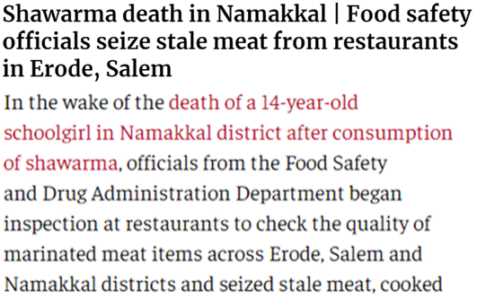

Figure 1: Snapshot of the news article.[*[Link]*](https://www.thehindu.com/news/national/tamil-nadu/shawarma-death-in-nammakal-food-safety-officials-seize-stale-meat-from-restaurants-in-erode-salem/article67321929.ece)

Figure 2: Microscopic images of the bacteria commonly found in stale meat

Figure 3: Traditional Model Results

Figure 4: The Architecture Diagram of Self-built ANN Model

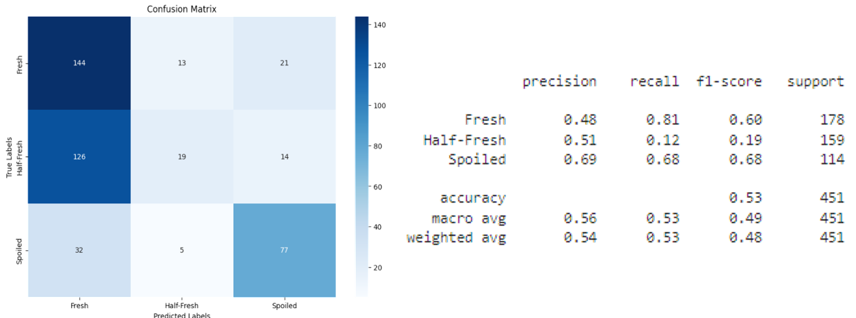

Figure 5: Classification Performance of Self-built ANN Model

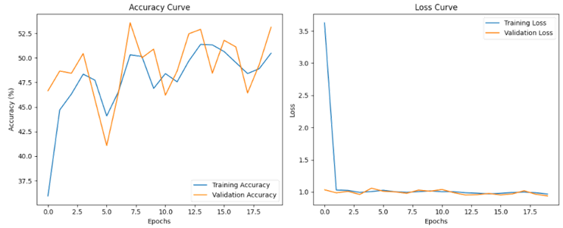

Figure 6: Training and Validation Accuracy and Loss Curves

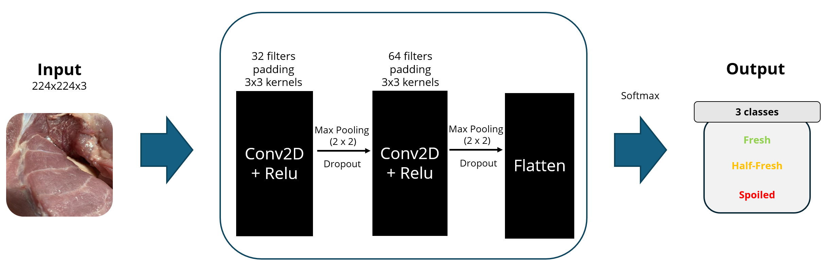

Figure 7: The Architecture Diagram of Self-built CNN Model

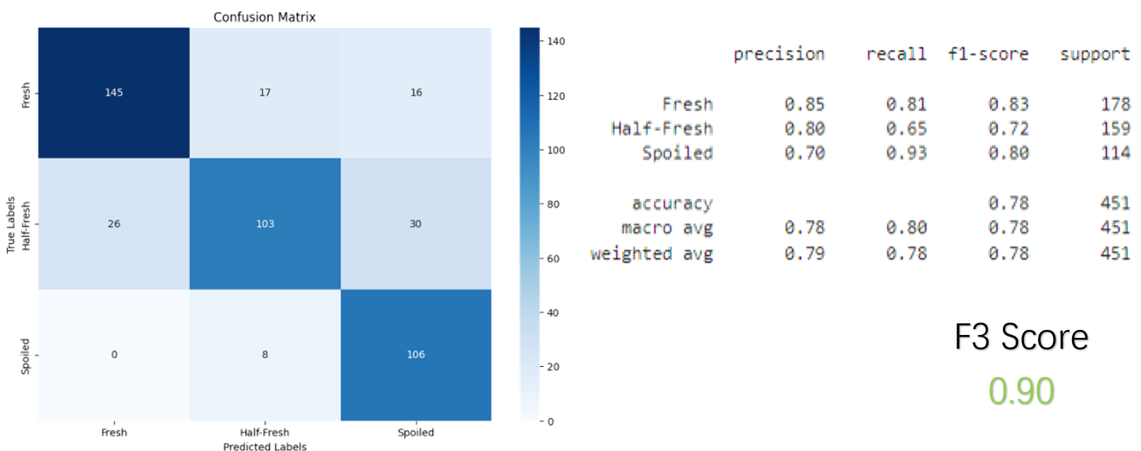

Figure 8: Classification Performance of Self-built CNN Model before Fine-tuning

Figure 9: Classification Performance of Self-built CNN Model after Fine-tuning

Figure 10: Comparison of pre-trained models

Figure *11*: Confusion matrix of ResNet50 model

Figure *12*: Classification report of ResNet50 model

Figure *13*: Accuracy Curve and Loss Curve of ResNet50 model

Figure *14*: Confusion matrix of EfficientNetB0 model

Figure *15*: Classification report of EfficientNetB0 model

Figure *16*: Accuracy Curve and Loss Curve of EfficientNetB0 model

Figure *17*: Confusion matrix of DenseNet121 model

Figure *18*: Classification report of DenseNet121 model

Figure *19*: Accuracy Curve and Loss Curve of DenseNet121 model

Figure *20*: Confusion matrix of Xception model

Figure *21*: Classification report of Xception model

Figure *22*: Accuracy Curve and Loss Curve of Xception model

Figure *23*: Confusion matrix of VGG 16 model

Figure *24*: Classification report of VGG 16 model

Figure *25*: Accuracy Curve and Loss Curve of VGG 16 model

Figure 26: Data Augmentation Techniques in Fine-tuned Model

Figure 27: Confusion Matrix for Fine-tuned Model

Figure 28: Accuracy Curve and Loss Curve for Fine-tuned Model

Figure 29: ChatGPT Performance Reference

Figure 30: Summary of the table results and the approved models

1. *Schoolgirl dies after consuming shawarma in Namakkal, 43 others hospitalized*. A snapshot of the news article is provided in the appendix as ***Figure 1.***
2. https://www.kaggle.com/datasets/vinayakshanawad/meat-freshness-image-dataset
3. Given the widespread availability of smartphones (with photo-taking capabilities), thus the cost of entry for using such methods are expected to be relatively low.